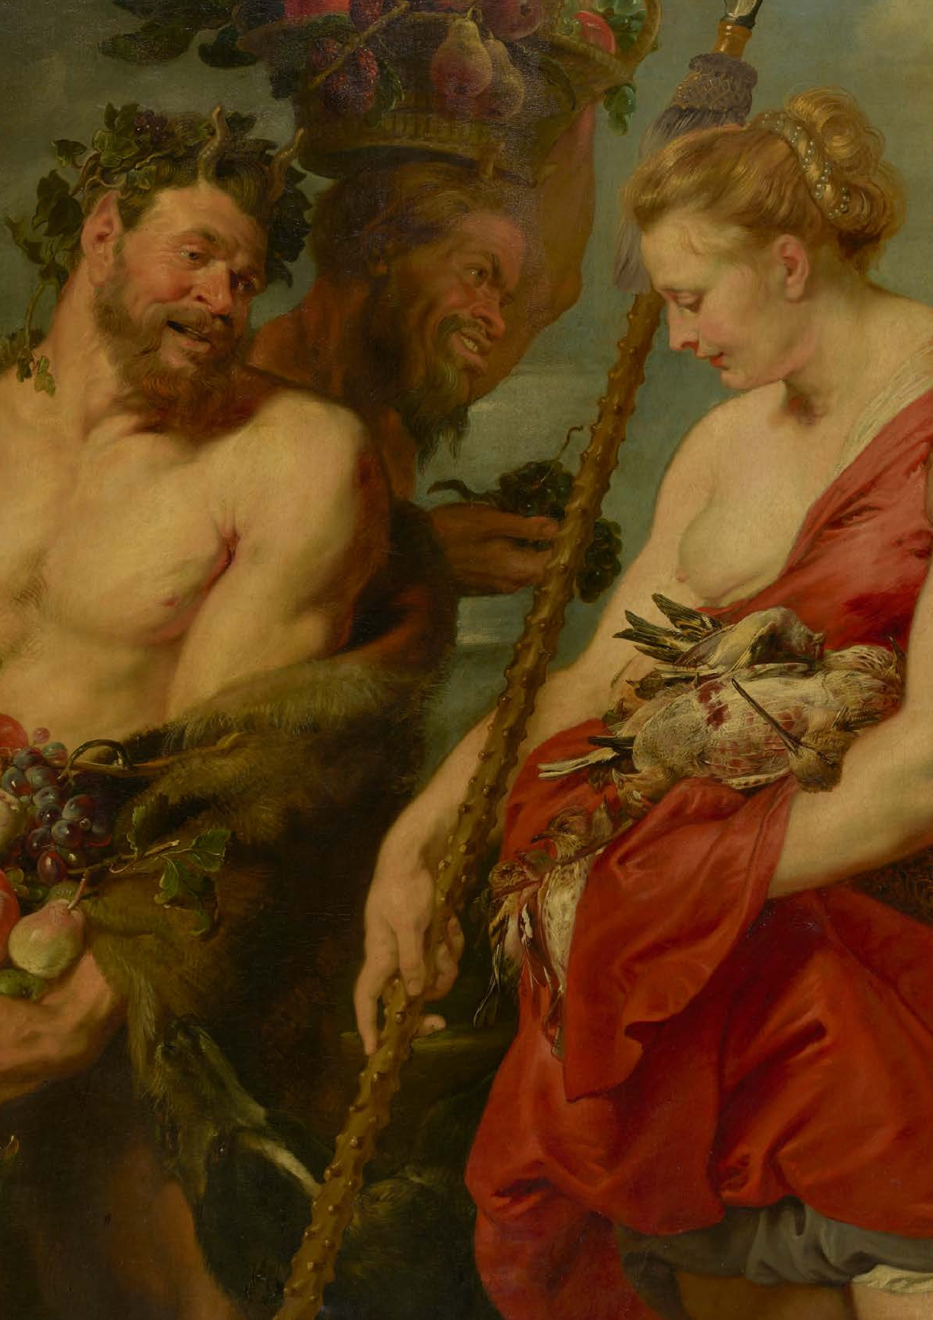
#
VisitDresden
HIGHLIGHTS
sdenElbland
#
Dre
2027
2027

is marked by anniversaries. The Old Masters Picture Gallery is celebrating the
450
th birthday
of Peter Paul Rubens
with a special exhibition. The
200
th anniversary of Ludwig
van Beethoven's death
, on the other hand, is the occasion for numerous concerts. The
Dresden
Music Festival
enjoys an excellent reputation and, on the occasion of its
th anniversary
50
, will
be using the entire city as a stage for a diverse programme. Culture in Dresden Elbland thrives on its diversity. The
Deutsche Hygiene-Museum
special exhibition
MAMA
explores what it means to become or be
a mother today. And at the
‚Erlebnisweingut‘ in Wackerbarth Castle

in Radebeul,
built 300 years ago,
the combination of culture and enjoyment is a living tradition – it has been

welcoming guests every day for 25 years.
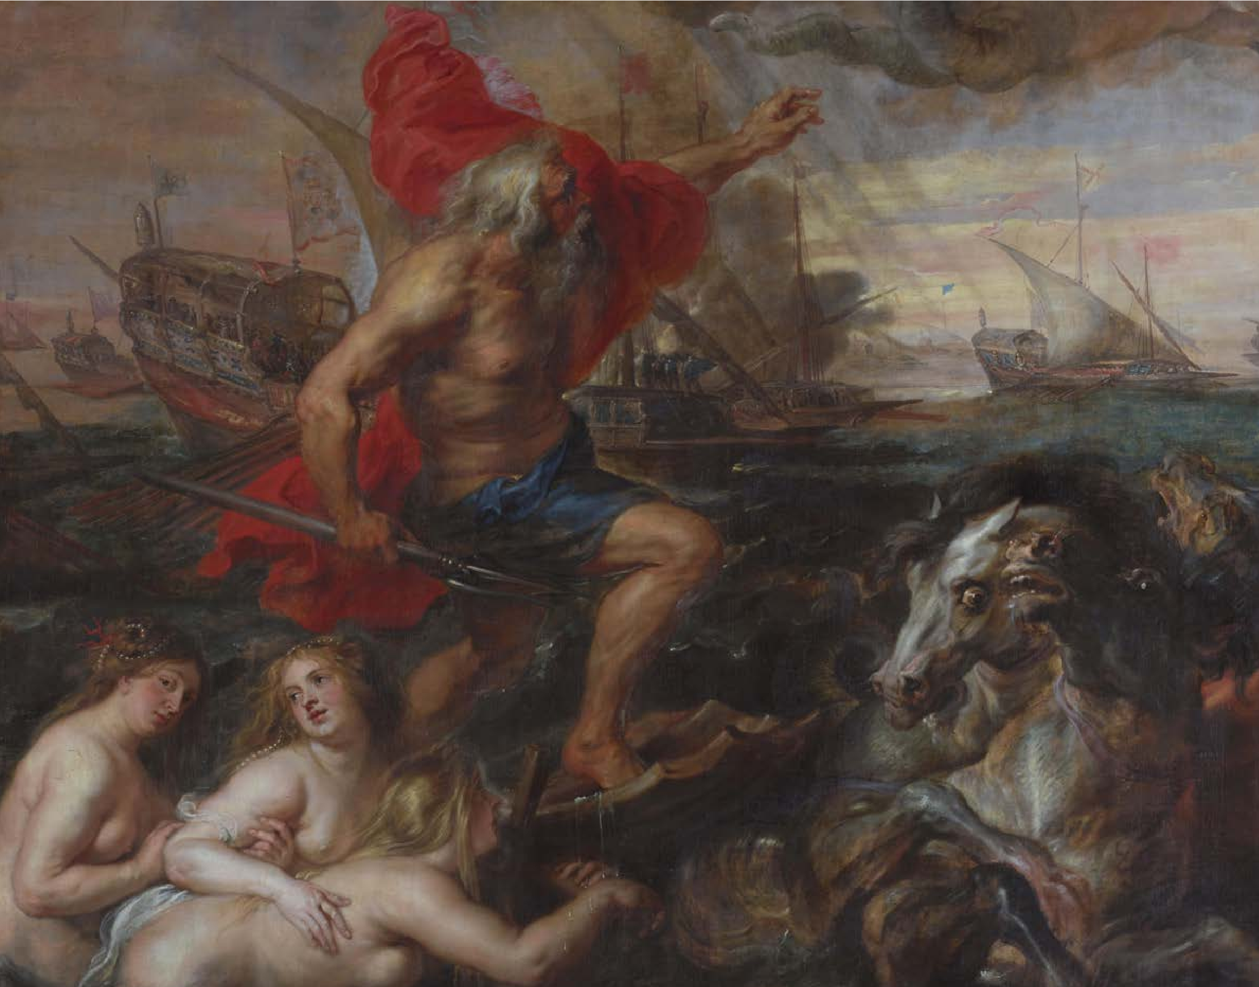
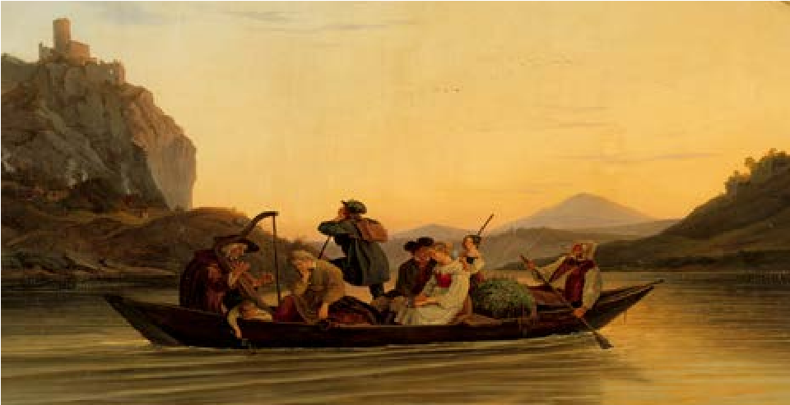
HIGHLIGHTS
RUBENS. A GLOBAL SUPER-
STAR IN DRESDEN!
25
th June 2027 to 9th January 2028
// www.skd.museum
2027
will mark the 450th anniversary of the birth of Peter
Paul Rubens (1577–1640), the great innovator of Euro
-
pean painting. Dresden will be honouring the occasion
with a major special exhibition. The Old Masters Picture
Gallery of the Dresden State Art Collections is planning a
representative display comprising around 100 works in
collaboration with German and international partners.
The painter's major works in Dresden, such as ‘The Drun
-
ken Hercules’, ‘The Old Woman with the Charcoal Brazier’
and ‘The Boar Hunt’, will form the centrepiece of the exhi
-
bition and will be supplemented by high-calibre loans. Af
-
ter several spectacular restorations, the public will be pre
-
sented with a new image of Dresden's important Rubens
collection and a comprehensive insight into the multiface
-
ted oeuvre of artist, diplomat and cosmopolitan Rubens.
LUDWIG RICHTER.
IDYLL AS UTOPIA
November 2027 to April 2028
// www.skd.museum
With his depictions of simple life, Romantic artist Ludwig
Richter inspired fantasies and longings unlike any other
painter of his time. Richter depicted the happiness and
contentment found in the harmony between humankind
and nature in vibrant colours. His paintings The Bridal

Procession in Spring and The Crossing at Schreckenstein
form part of our collective visual memory. The Albertinum
is celebrating his optimistic worldview with a major

special exhibition.
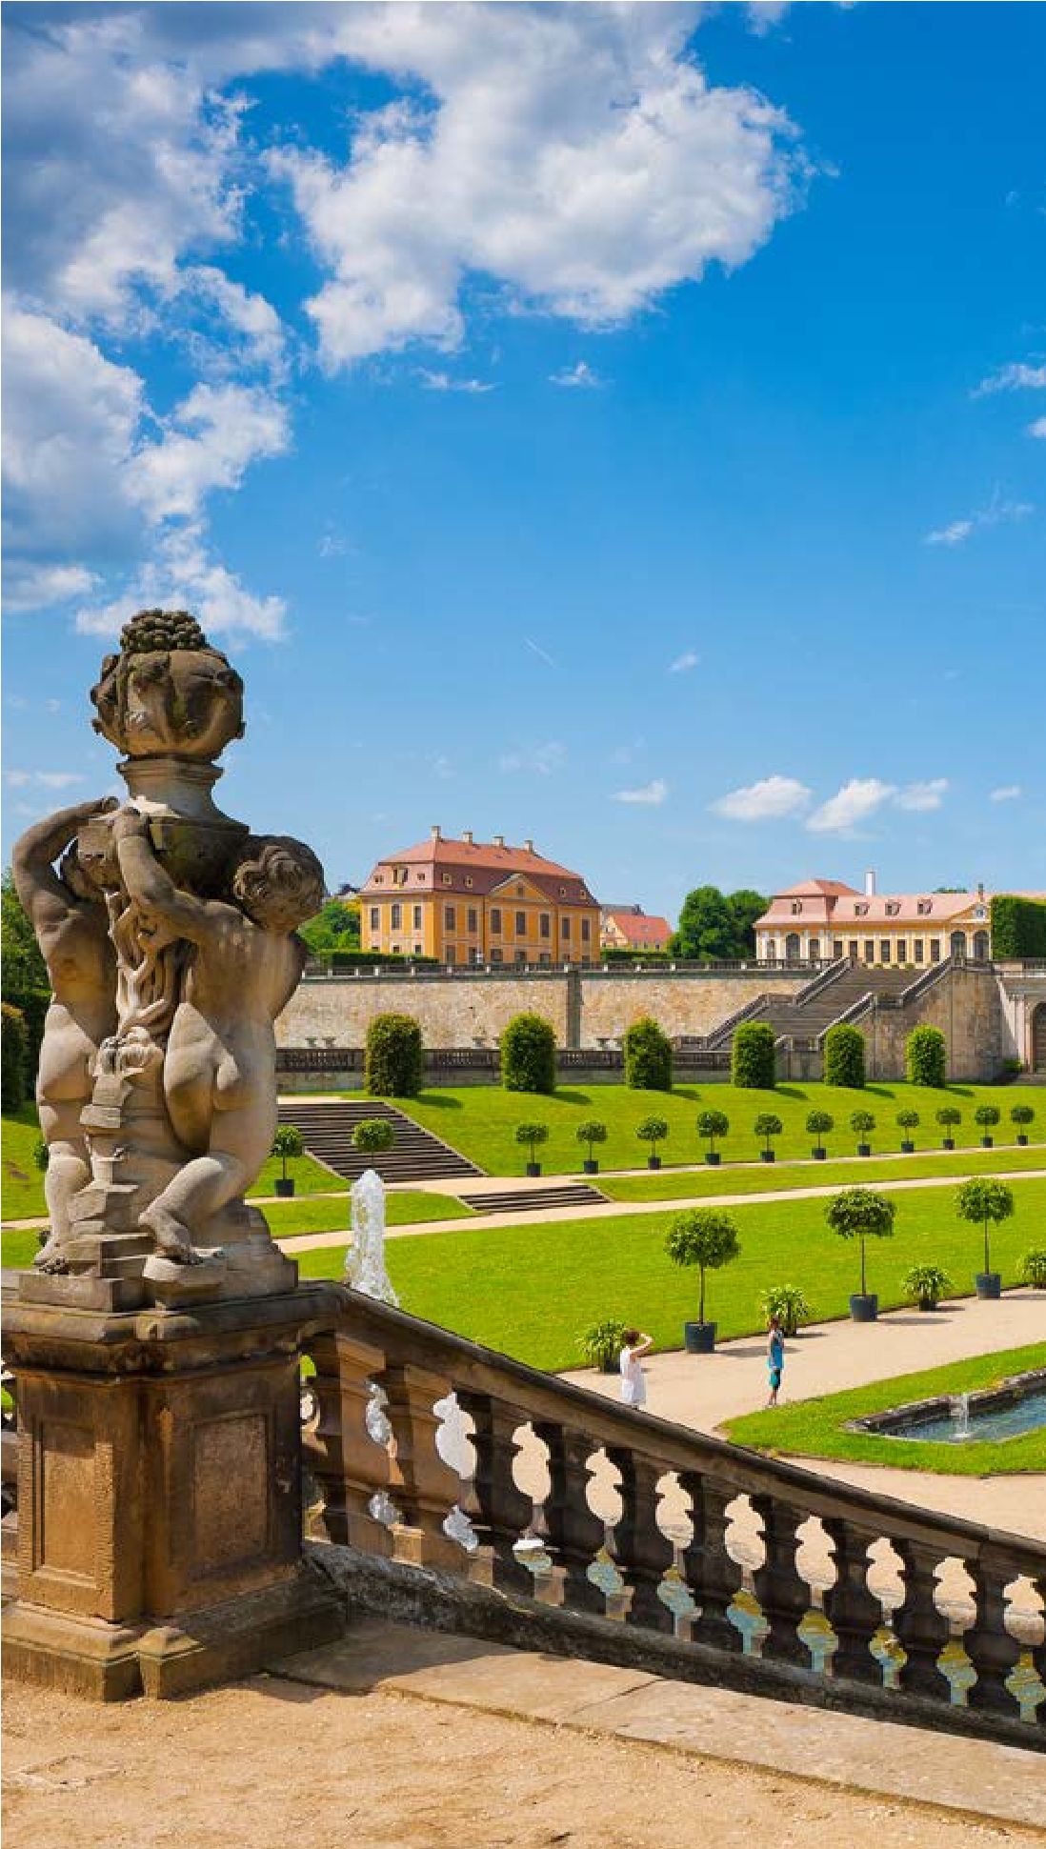
SEMPEROPER DRESDEN
www.semperoper.de
14
th to 17th April, 28th to 30th April and 1st May 2027
Beethoven Cycle I & II
The Saxon State Orchestra, conducted by Daniele Gatti,

performs all of Beethoven's symphonies.
th, 8th, 15th and 21st May 2027
5
Giuseppe Verdi: Un ballo in maschera
Verdi combines the cheerful and burlesque with the tragic
and sombre to create a unique musical flow.
Premiere on the 24th of April, with further performances
on the 27th of April and the 4th, 9th, 14th and 20th of May

2027
Ferdinando Paër: Leonora

Paër's opera ‘Leonora’ premiered in Dresden in 1804 and

later served as the model for Beethoven's ‘Fidelio’.
Premiere on the 29th of May, with further performances
on the 1st, 4th, 6th, 12th, 20th, 25th and 27th of June, and
on the 1st and 8th of July 2027.
Kinsun Chan: Cinderella
Kinsun Chan stages the classic fairy tale full of magic, emoti
-
on and optimism.
Premiere on the 26th of June, with additional perfor-
mances on the 29th of June and the 3rd, 7th and 10th of
July 2027
Richard Wagner: Rienzi, der Letzte der Tribunen
Rienzi fights against aristocratic rule, but the ideals of the
people are lost in the power struggle.
FESTIVAL WEEK DEDICATED
TO THE ORDER OF THE
WHITE EAGLE
HISTORY THAT BUILDS BRIDGES

nd to 8th August 2027
2
Augustus the Strong had nothing less than a Saxon

Versailles in mind when he purchased the Baroque garden
of Großsedlitz near Pirna at the beginning of the 18th cen
-
tury and completely redesigned it. Although unfinished,
the complex with its two orangeries, water features and
around 60 sculptures is one of the most remarkable gar
-
den ensembles in Germany. The park gained political

significance in 1727 when the Saxon Prince-Elector, who
was also King of Poland at the time, instituted the Order of
the White Eagle here. Created at the time with the aim of

honouring the vision, courage and independence of

Polish, Lithuanian and Saxon nobles, the order has been
restored in Poland as the country’s most important award
today. Reason enough to celebrate the anniversary with a
festive event that combines historical and scientific analy
-
sis with moments of enjoyment. Großsedlitz thus beco
-
mes a lively meeting place between the two European
neighbours, Saxony and Poland.
200
TH ANNIVERSARY OF
BEETHOVEN‘S DEATH
www.visit-dresden-elbland.de
When the 200th anniversary of Ludwig van Beethoven‘s
death is commemorated across Europe in 2027, Dresden
will also be making its contribution. Although the compo
-
ser only spent a few days in the city, it was Schiller‘s decla
-
ration of friendship to Christian Gottfried Korner, who lived
here, that Beethoven set to music. The ‘Ode to Joy’ thus
became the final chorus of his 9th Symphony. Richard
Wagner made the work popular in Dresden by performing
it every year on Palm Sunday.
Beethoven‘s opera ‘Fidelio’ also played a special role in
Dresden. Premiered in Vienna in 1805, the work was heard
for the first time in Dresden in 1815. Wagner became ac
-
quainted with ‘Fidelio’ in Dresden and was significantly in
-
fluenced by it in his development as an opera composer.
In 2027, Beethoven‘s works can be heard and enjoyed
again in Dresden.
HIGHLIGHTS
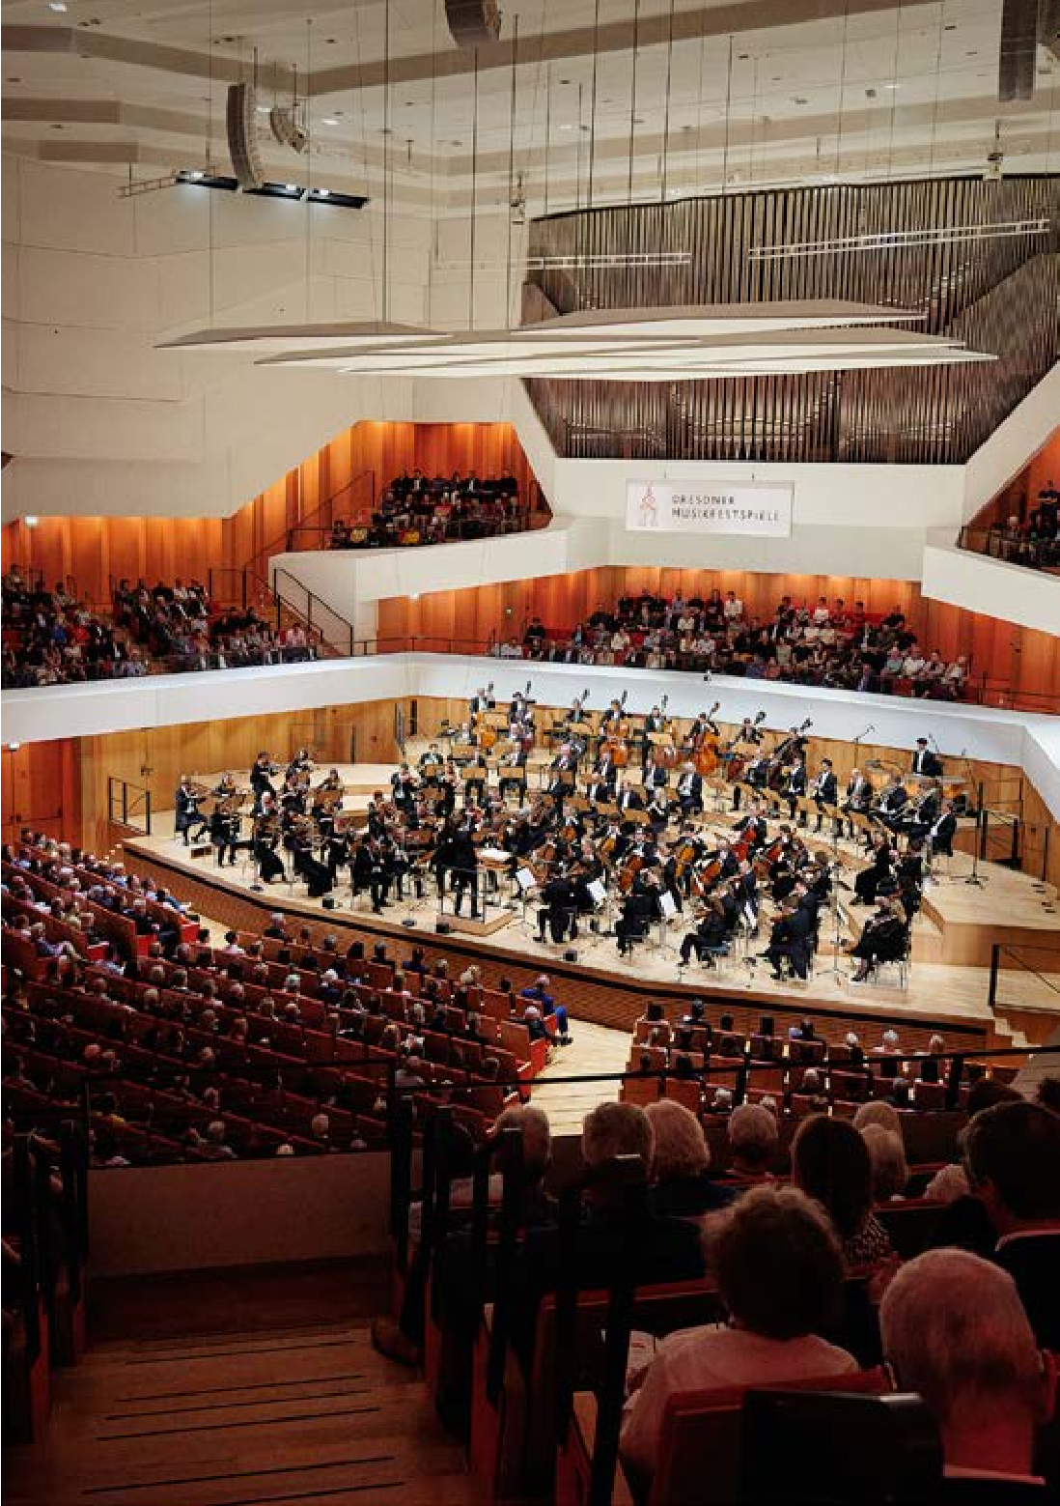
CONCERTS
THE DRESDEN PHILHARMONIC
ORCHESTRA
KULTURPALAST DRESDEN
www.dresdnerphilharmonie.de
23
rd February 2027
Stars at the Piano:
RUDOLF BUCHBINDER
LUDWIG VAN BEETHOVEN
At the invitation of the Dresden Philharmonic Orchestra
in collaboration with DK Deutsche Klassik
12
th and 13th March 2027
GRIEG PIANO CONCERTO
Felix Mendelssohn Bartholdy:

Overture to ‘A Midsummer Night's Dream’
Edvard Grieg: Piano Concerto in A minor

Edward Elgar: ‘Falstaff’ Symphonic Study

Conductor: Vasily Petrenko

Eva Gevorgyan (piano)

Dresden Philharmonic
28
th March 2027
Easter Symphony Concert
ENIGMA VARIATIONS
Edward Elgar: Overture to ‘In the South’
Joaquín Rodrigo: Concierto de Aranjuez for

Guitar and Orchestra
Edward Elgar: ‘Enigma’ Variations
Conductor: Adam Hickox
Pablo Sainz Villegas (guitar)
Dresden Philharmonic Orchestra
th and 9th May
2027
8
TCHAIKOVSKY 5th
Karl Amadeus Hartmann: ‘Concerto funebre’
for violin and string orchestra
Pyotr Tchaikovsky: Symphony No. 5 in E minor
Conductor: Michael Sanderling

Christian Tetzlaff (violin)

Dresden Philharmonic Orchestra
29
th and 30th May
2027
MAHLER 9th
Gustav Mahler: Symphony No. 9 in D major
Conductor: Sir Donald Runnicles
Dresden Philharmonic Orchestra
11
2027
th and 12th September
ROMANTIC NIGHT
Great romantic repertoire
Conductor: Sir Donald Runnicles
Olivier Latry (organ)
Dresden Philharmonic Orchestra
TH DRESDEN
50
MUSIC FESTIVAL
13
th May to 13th June 2027
// www.musikfestspiele.com
2027
th May
14
Nylund – Staatskapelle Berlin –
Thielemann
Works by Franz Liszt (Festklänge, Les Préludes, Orpheus)
and Richard Strauss (Three Hymns)
Camila Nylung (soprano), Staatskapelle Berlin,
Conductor: Christian Thielemann
22
nd May
2027
Vogler – Orchestre Philharmonique
de Radio France – Gražinytė-Tyla
Works by Claude Debussy, Camille Pépin and
Peter Tchaikovsky

Jan Vogler (violoncello),

Orchestre Philharmonique de Radio France,
Conductor: Mirga Gražinytė-Tyla
2027
th May
25
Mutter – Razavi – Soltani – Danish
National Symphony
Orchestra – Luisi
Works by Golfam Khayam and Peter Tchaikovsky

Anne-Sophie Mutter (violin), Muriel Razavi (viola)
and Kian Soltani (cello),
Danish National Symphony Orchestra,
Conductor: Fabio Luisi
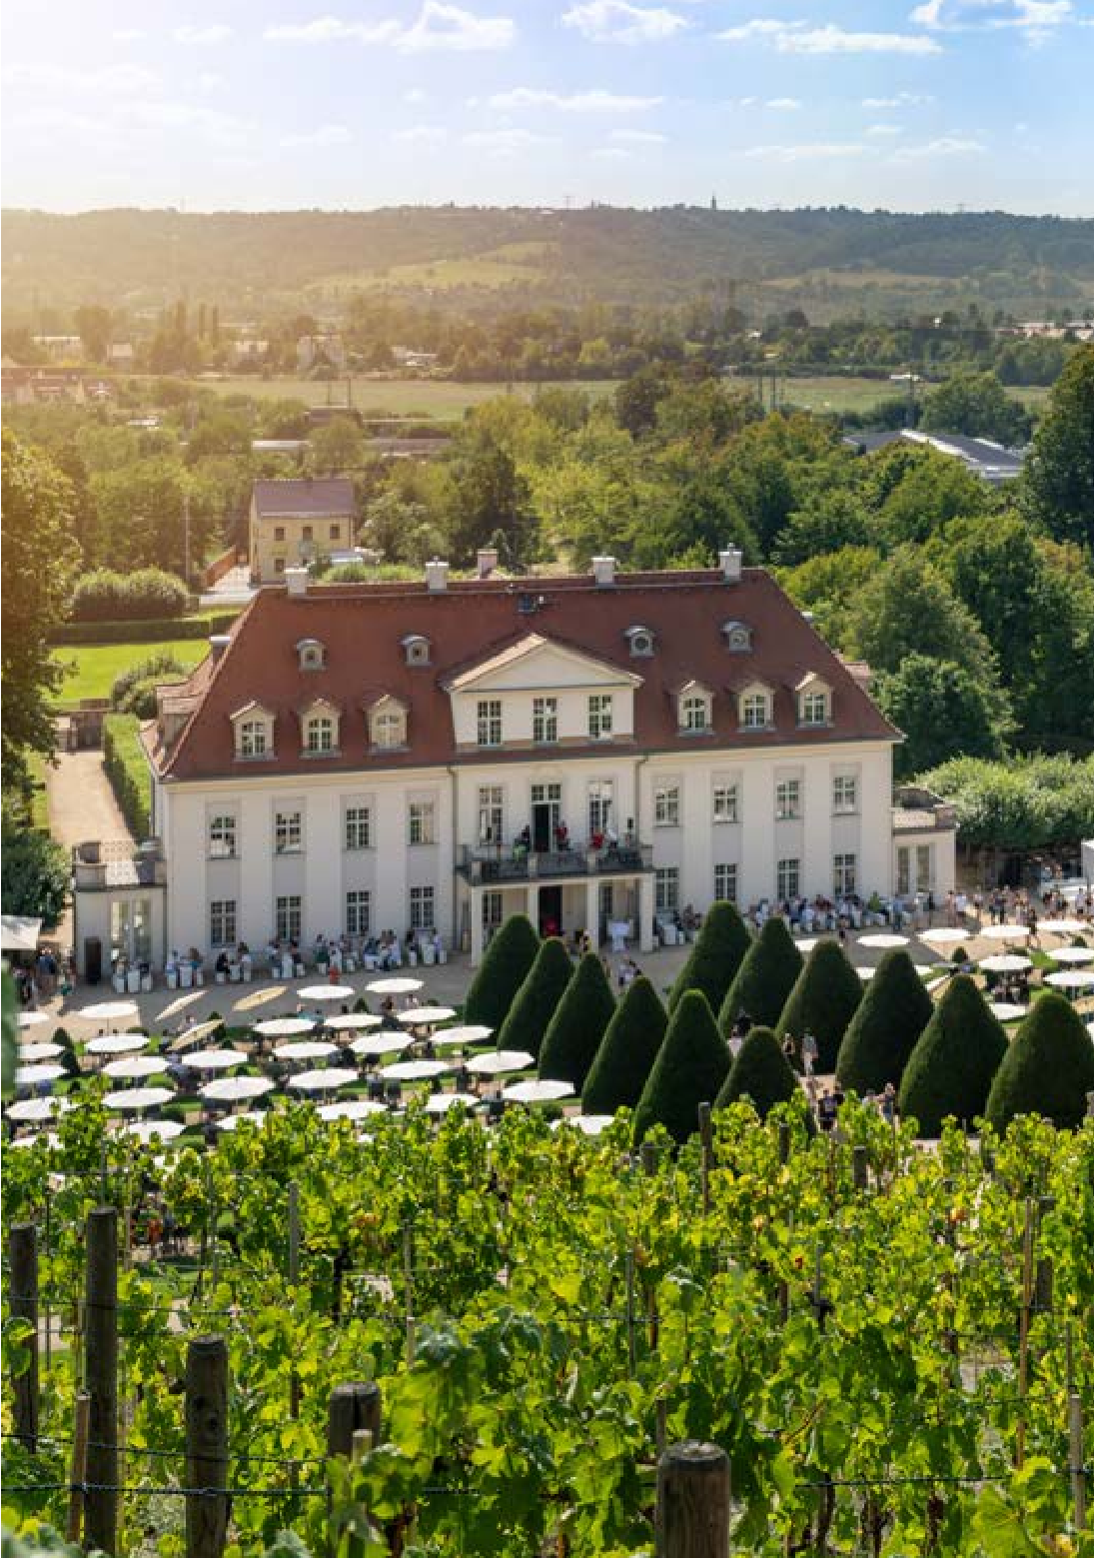
HIGHLIGHTS
300
YEARS OF
WACKERBARTH CASTLE
25
YEARS OF EUROPE'S FIRST
‘ERLEBNISWEINGUT’
www.schloss-wackerbarth.de
Wackerbarth Castle, once the site of Baroque court festivi
-
ties, is now Europe's first ‘Erlebnisweingut’ (Heritage Viney
-
ard). 300 years ago, Count von Wackerbarth, a close confi
-
dant of Augustus the Strong, had the castle and gardens
built in the Saxon Elbe Valley, which has been characterised
by viticulture for over 850 years. French cellar masters
brought the art of sparkling wine production to Radebeul,
where grape juice is still associated with fine living and en
-
joyment today.
January/February and November/December 2027

Wine & Light at Wackerbarth Castle
March/April 2027

Sparkling Wine Spring at Wackerbarth Castle
May to October 2027
Wine Summer at Wackerbarth Castle
8
th May
2027
German Sparkling Wine Day at Wackerbarth Castle
DEUTSCHES HYGIENE-

MUSEUM DRESDEN
www.dhmd.de
13
th March 2027 to 26th March
2028
MAMA
Running the house, looking after the kids, pursuing a ca
-
reer and finding time for oneself: mothers are under tre
-
mendous pressure in our society. The special exhibition
‘MAMA’ examines the issue of what it is like to become or
be a mother today. Because motherhood affects us all –
as children, parents or part of society. The exhibition,
which is based on the show presented at the Kunstpalast
Düsseldorf in 2025, combines everyday objects, pop cul
-
ture videos and interactive infographics with historical
works of art and contemporary offerings by young artists.
EUROPEAN CENTRE
FOR THE ARTS HELLERAU
www.hellerau.org
April 2027
40
years of Dresden Days of
Contemporary Music
40
years after its founding in 1987, the international festi
-
val "DTZM – Dresden Days of Contemporary Music" will
celebrate its anniversary in April 2027 at the Festspielhaus
HELLERAU and other venues in Dresden – curious, expe
-
rimental, surprising and, as always, with plenty of reso
-
nance for ears, mind and heart.
FRAUENKIRCHE
DRESDEN
www.frauenkirche-dresden.de
2027
th April
30
Anima Eterna
Works by Maddalena Sirmen, Regina Strinasacchi,
W. A. Mozart and others

Violin: Midori Seiler
th June 2027
18
Hope — Bezuidenhout — Zurich
Chamber Orchestra
Works by Felix Mendelssohn Bartholdy and W. A. Mozart
Piano: Kristian Bezuidenhout
Violin and conductor: Daniel Hope
th July 2027
16
Gutman Tango Quintet
17
th August 2027
Hope — Gstaad Festival Orchestra
Works by Antonio Vivaldi and Max Richter

Violin: Daniel Hope
11
th December
2027
Hope — Belgrade Chamber
Orchestra
Works by Vivaldi, Grieg, Rutter and international
Christmas carols

15th to 17th January 2027 European Short Track Speed
Skating Championships 2027
JOYNEXT Arena
Until 22nd February 2027 DRESDNER WINTER: A paradise for the whole family
Konzertplatz Weißer Hirsch www.konzertplatz-weisser-hirsch.de/winter
January to the end of February 2027 Dresdner Winterfest
Altmarkt www.dresdner-winterfest.de
January and February 2027 Winter Illuminations at the
Hoflößnitz vineyards
Weingut Hoflößnitz, Radebeul www.hofloessnitz.de
January and February 2027 Festival of Wine & Light at
Wackerbarth Castle
Schloss Wackerbarth, Radebeul www.schloss-wackerbarth.de
5th February 2027 SemperOpernball www.semperopernball.de
5th to 7th February 2027 Elbe Venetian Carnival
350 years of ‘Italian Carnival’ in
Dresden
Dresden historic city centre www.elbvenezianischercarneval.de
6th/7th February 2027 Festival of Mulled Wine
www.weindoerfer.de
6th February 2027
3rd Pirna Winter Courtyard Night www.pirna.de/hofnacht
March and April 2027
Springtime Festival of Sparkling
Wine at Wackerbarth Castle
Schloss Wackerbarth, Radebeul www.schloss-wackerbarth.de
10th to 14th March 2027 Humor Zone Dresden
Featuring more than 100 standup comedians on 15 different stages in the city. Under the patronage of Olaf Schubert www.humorzone.de
April 2027
40 Years of Dresden Days of Contemporary Music
Curious, experimental, surprising and, as always, with plenty of reverberation and echo for the ears, head and heart
HELLERAU – Europäisches Zentrum der Künste www.hellerau.org
20th/21st April 2027
Medieval Spectacular in Altzella Monastery Park
The Middle Ages are back for a new season. There will be jugglers, demonstrations by craftsmen, a medieval market and keenly contested jousting tournaments www.kloster-altzella.de
EVENTS IN DRESDEN ELBLAND
10th/11th April 2027
Dresden Steam Locomotive Convention
The prelude to the main event is a nighttime photo shoot for enthusiasts on 9th April (7pm - 9pm)
Dresden Railway Museum www.dresdner-dampfloktreffen.de
13th to 18th April 2027 Filmfest Dresden
International Short Film Festival www.filmfest-dresden.de
24th April 2026 Elbe Day
Music festival on the banks of the Elbe River to commemorate the anniversary of the historic encounter of the
American and Russian armies in 1945
Torgau (Elbe Embankment) www.elbeday.de
23rd April 2027
Lebendiges Canalettobild
(Canaletto living tableau)
Bernardo Bellotto's famous painting ‘Pirna Market Square’ (1753) is reenacted by locals dressed up in historical attire, with many original and authentic details from the time
Pirna market square www.pirna.de
25th April 2027
VVO Upper Elbe Marathon
Scenic marathon along the Elbe Cycle Path from Saxon Switzerland to Dresden www.oberelbe-marathon.de
1st May 2027
Parade of the Fleet of the Saxon
Steam Navigation Company
Terrassenufer, below Brühl’s Terrace, Dresden www.saechsische-dampfschifffahrt.de
May to October 2027
Summer Wine Festival at
Wackerbarth Castle
Schloss Wackerbarth, Radebeul www.schloss-wackerbarth.de
6th/7th May 2027
Altzella International
Blues & Rock Festival
Altzella Monastery Park https://bluesundrock-altzella.de
6th May 2027
Ascension Day Wine Tasting in Diesbar-Seusslitz
www.weindoerfer.de
7th to 9th May 2027 Karl May Festival
A weekend spent roaming the Wild West, with cowboys, country music and adventure aplenty
Radebeuler Lößnitzgrund www.radebeul.de
8th/9th May 2027 Meissen Art Festival
Meissen-Cölln www.hafenstrasse-meissen.de
8th May 2027
German Sparkling Wine Day at
Wackerbarth Castle
Schloss Wackerbarth, Radebeul www.schloss-wackerbarth.de
16th to 23rd May 2027
International Dixieland Festival
Europe's longest-running old-time jazz festival is staged at a wide variety of venues, including the zoo and
Dresden airport
Dresden www.dixielandfestival-dresden.com
13th May to 13th June 2027
50th Dresdner Musikfestspiele One of the largest and most prestigious classical music festivals in Europe www.musikfestspiele.com
22nd/23rd May 2027 Meissen Pottery Market
Meissen historic centre www.meissner-toepfermarkt.de
29th May 2027
Long Night of Art, Culture and
Architecture
Meissen historic centre www.stadt-meissen.de
June to August 2027
Summer of Art at the Red House
Moritzburg www.kulturlandschaft-moritzburg.de
12th/13th 2027
Moritzburg Castle Triathlon
From Barockman long distance to
Olympic distance to triathlon
Around Moritzburg Castle www.schlosstriathlon.de
12th to 14th June 2026
Meissen Literary Festival
Germany's biggest open-air festival of literature
Meissen historic centre www.meissener-kulturverein.de
11th June to 13th August 2027 Meissen Summer of Culture www.stadt-meissen.de
12th/13th June 2027
Radebeuler Kasperiade
Puppet show for young and old featuring skilled performers from all over Germany
Kultur-Bahnhof Radebeul www.radebeul.de
12th/13th June 2027
Open Days at the Radebeul Vineyards
The winegrowers of Radebeul extend a warm welcome
www.radebeuler-winzer.de
18th to 20th June 2027 Pirna Town Festival
A full three-day programme of events in Pirna’s old town
Pirna historic centre www.pirna.de/stadtfest
19th June 2027
Dresden Museum Night
From 6pm through to 1am, 40 museums will be open to the public shuttle buses and trams will be running between the various institutions www.dresden.de/museumsnacht
19th/20th June 2027 Silbermond – 25 Years
Rudolf Harbig Stadium www.rudolf-harbig-stadion.com/highlights
21st June 2027
Fête de la Musique
Music lovers gather at delightful spots to celebrate the summer solstice
Various locations throughout Radebeul www.radebeul.de
25th to 27th June 2027
Riverside Festival Dresden
Stroll along the five miles of river bank between Loschwitz and Pillnitz, featuring theatre and concerts as you go www.elbhangfest.de
25th June to 30th August 2027 Film Nights on the Elbe Embankment
Open-air stage with cinema and concerts
Königsufer, Dresden www.filmnaechte-am-elbufer.de
26th/27th June 2027 Kunst geht in Gärten: Art goes into gardens
Radebeul artists open their gardens to the public and showcase their art and studios
Various locations throughout Radebeul www.radebeul.de/gaerten
26th June to 4th July 2027 Meissen Castle Festival
Musical theatre, plays and concerts in a historic setting
Domplatz, Meissen www.burgfestspielemeissen.de
26th/27th June 2027 Flower and Garden Show
Altzella Monastery Park www.kloster-altzella.de
4th July to 22nd August 2027 Altkötzschenbroda Open-Air Summer Stage
Radebeul www.radebeul.de
July to August 2027 Palace Summer
This huge festival offers art, culture and education – all free of charge www.palaissommer.de
9th to 11th July 2027 Cogwheels and Top Hats: A journey back in time to the era of Jules Verne Steampunk art and culture festival
Meissen Cathedral Square www.zahnrad-und-zylinder.de
17th July 2027 Dresdner Schlössernacht
Elbschlösser Dresden www.dresdner-schloessernacht.de
17th/18th July 2027 Gassenzauber: Street Theatre in Meissen Squares and alleyways become the setting for fascinating international theatre worlds
Meissen historic centre www.theater-meissen.de
17th to 25th July 2027
International Saxonian Singer
Academy
Schloss Hartenfels, Torgau www.tic-torgau.de
6th to 22nd August 2027 Moritzburg Festival
The unique atmosphere of this chamber music festival stems from its innovative spirit, musical dynamism and special venues Artistic director: Jan Vogler www.moritzburgfestival.de
EVENTS IN DRESDEN ELBLAND
7th August 2027 Night of the Pirna Courtyards Pirna shows its hidden side: restored courtyards as rare architectural treasures.
Pirna town centre www.pirna.de/hofnacht
20th to 22nd August 2027 CANALETTO: Dresden City Festival
Dresden city centre www.dresdner-stadtfest.com
21st/22nd August 2027 Music & Stallions at Moritzburg
Landgestüt Moritzburg www.saechsische-gestuetsverwaltung.de
28th/29th August 2027
Arts and Crafts Market Altzella
Altzella www.kloster-altzella.de
28th/29th August 2027
Open Winery Days
Estates between Pirna and Diesbar-Seußlitz www.visit-dresden-elbland.de
2nd September 2027
Cocktail Night in the
Baroque Quarter
Baroque Quarter, Dresden Neustadt www.barockviertel.de
3rd to 5th September 2027
Weinböhla Winegrowers’ Street
Festival
On and around the church square www.weinboehla.de
September 2027
Moritzburg: Parade of the
Stallions
Parade ground of the Moritzburg State Stud www.saechsische-gestuetsverwaltung.de
11th/12th September 2027 Federweißerfest at
Wackerbarth Castle
Festival of freshly pressed wines at Schloss Wackerbarth, Radebeul www.schloss-wackerbarth.de
11th/12th September 2027
Federweißermeile Diesbar-Seußlitz www.weindoerfer.de
11th/12th September 2027 Historical Festival Play:
‘The Saviour’
In 1639, midway through the Thirty
Years' War. Pirna pharmacist Theophilius Jacobaer saved his home town from destruction. This story is brought to the stage in his honour
Pirna historic centre www.pirna.de
17th to 19th September 2027 Autumn Wine Festival plus
International Itinerant Theatre Festival
Spectacular culinary weekend combining wines from Saxony with international theatre
Radebeul-Altkötzschenbroda www.radebeul.de
17th to 19th September 2027
Meissen Wine Festival
Meissen historic centre www.meissner-weinfest.de
23rd September to 9th October 2027 Pichmännel Oktoberfest
Saxony’s largest beer tent festival with traditional costumes, music and fairground atmosphere
RINNE Dresden, Ostragehege www.pichmaennel-oktoberfest.de
25th September 2027 Meissen Fashion Night
Meissen historic centre www.meissner-modenacht.de

1st October to 21st November 2027 Dresden Jazz Days www.jazztage-dresden.de
1st to 3rd October 2027
Town and Lights Festival
“Torgau in Bloom”
Torgau city centre www.torgau.de
1st to 10th October 2027 Heinrich Schütz Music Festival
Dresden, Torgau and other nearby venues www.schuetz-musikfest.de
1st to 10th October 2027
Kurfürstliches Winegrowers’
Festival” at Hoflößnitz
Radebeul, Weingut Hofl ößnitz www.hofl oessnitz.de
2nd/3rd October 2027
Saxon Cheese & Specialities
Market
Altzella www.kloster-altzella.de
30th/31st October 2027
Moritzburg Fish and Forest Festival
www.fisch-waldfest-moritzburg.de
31st October 2027
Dresden Marathon
www.dresden-marathon.com
31st October 2027 “Abdampfen” (Letting off Steam):
End-of-the-Season Steamship
Parade
Terrassenufer, below Brühl’s Terrace, Dresden www.saechsische-dampfschifffahrt.de
November and December 2027 Festival of Wine & Light at Wackerbarth Castle
Europe’s first ‘Erlebnisweingut’ (heritage vineyard) transforms itself into a world of glamour, music and entertainment with its winter illuminations
Schloss Wackerbarth, Radebeul www.schloss-wackerbarth.de
November 2027 through to
January 2028
Christmas Garden Dresden
Thousands of lights transform Pillnitz
Palace and Park into a fairytale world
Pillnitz Palace and Park www.christmas-garden.de/dresden
3rd to 7th November 2027
DAVE Festival of Club Culture
DAVE brings together music, media, technology and other art forms to develop new event concepts. What makes the festival so special is that the events take place not only in clubs,
EVENTS IN DRESDEN ELBLAND
but also in unusual venues such as churches
Various locations in Dresden www.dave-festival.de
6th/7th November 2027
Radebeul Wine Warming
Radebeul turns into a culinary destination, inviting visitors to explore the wine town www.radebeul.de
7th November 2027
Radebeul Graphics Market
Around 100 artists from Radebeul and the region present their work www.radebeul.de
22nd November to
24th December 2026 Christmas in Meissen
Meissen historic centre www.meissner-weihnacht.de
23rd November to
30th December 2027 Pirna Canaletto Market
Pirna market square www.pirna.de
24th November to
24th December 2027
593rd Dresden Striezelmarkt
Dresden's largest Christmas market is also Germany's oldest
Altmarkt Dresden www.visit-dresden-elbland.de/weihnachten
26th to 28th November
3rd to 5th December
10th to 12th December 2027
Christmas Market: Glittering
Lights and Magical Stalls
The historic village green is transformed into a magical and romantic Christmas world
Altkötzschenbroda, Radebeul www.weihnachtsmarkt-radebeul.de
3rd to 5th December 2027 Weinböhla Christmas Market
On and around the church square www.weinboehla.de
3rd to 5th December 2027
Manufacturing Magic at Wackerbarth Castle
Special Christmas market with selected regional and national artisans and a cultural programme by Landesbühnen Sachsen
Schloss Wackerbarth, Radebeull www.schloss-wackerbarth.de
4th December 2027
Dresden Stollen Festival
www.dresdnerstollen.com/de/stollenfest
10th to 12th December 2027
Moritzburg Christmas Market
A variety of crafts, original Christmas gift ideas and a colourful programme of events www.weihnachtsmarkt-moritzburg.de
18th/19th December 2027
Christmas for the Whole Family at Hoflößnitz Winery
Atmospheric Christmas cultural programme for children, with theatre performances and live music
Weingut Hoflößnitz, Radebeul www.hofloessnitz.de
21st December 2027
Short Film Day 2027 Dresden
On the shortest day of the year, short film format in all its diversity is presented at unusual locations www.kurzfilmtag.com
23rd December 2027
Christmas Vespers in front of the Frauenkirche
Germany’s largest regular open-air church service to mark the beginning of the Christmas season
Neumarkt Dresden www.frauenkirche-dresden.de
All events in Dresden - Elbland can be found at: www.veranstaltungen.dresden.de www.visit-dresden-elbland.de/en
Contact us
Dresden Marketing GmbH
Messering 7, 01067 Dresden Tel +49 351 501730 info@marketing.dresden.de www.visit-dresden-elbland.de
Dresden Information
Dresden Information at the Frauenkirche
QF Passage Neumarkt 2, 01067 Dresden Hotline +49 351 501501
Monday to Friday 10am - 7pm Saturday 10am - 6pm, Sunday 10am - 3pm info@dresden.travel www.visit-dresden-elbland.de
Photo credits
Title: Peter Paul Rubens, Diana Returning from the Hunt, c. 1616 (detail), SKD, Gemäldegalerie Alte Meister, Photo:
SKD, Klut/Estel; p. 1: Peter Paul Rubens, “Quos ego” – Neptune Calming the Waves, c. 1635 (detail), SKD, Gemäldegalerie Alte Meister, Photo: SKD, Klut/Estel; p. 1: SKD, Galerie Neue Meister, Photo: Jürgen Karpinski. Ludwig Richter, The Crossing at Schreckenstein, Dresden, 1837.;
p. 2 (top): Marco Borggreve; p. 2 (bottom): Sylvio Dittrich;
p. 3 (top): Stephan Floss; p. 4: C.-I. Mokry

