FOR IMMEDIATE RELEASE
6 JANUARY 2026

PANTHEON OF PUNDITS UNVEILED FOR TEAM WARNER BROS. DISCOVERY IN EUROPE FOR MILANO CORTINA 2026

- A legendary legion of winter sports experts boasting 109 Olympic medals line up to captivate viewers as part of WBD’s coverage of the Olympic Winter Games Milano Cortina 2026
- New original Olympic stories will introduce aspiring skiers and snowboarders to fans
- Live coverage of the Winter Olympics on WBD platforms starts on Wednesday 4 February

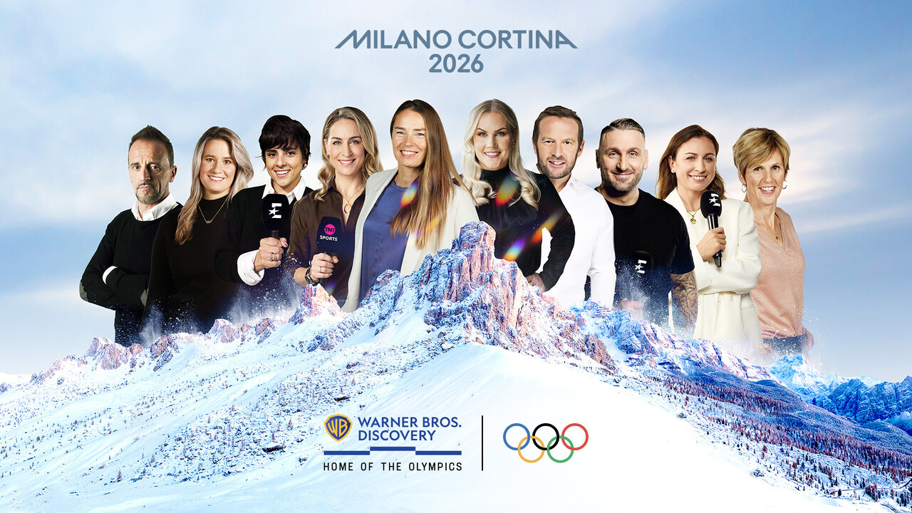
L-R Fulvio Valbusa (Italy), Natalie Geisenberger (Germany), Sara Hurtado (Spain), Amy Williams (UK), Tina Maze (International), Annina Rajahuhta (Finland), Jean-Pierre Vidal (France), Kevin Kuske (Germany), Justyna Kowalczyk-Tekieli (Poland), Sandrine Bailly (France)

With just one month to go until the world comes together in Italy to mark the Opening Ceremony at the Olympic Winter Games Milano Cortina 2026, today Warner Bros. Discovery (WBD) reveals the full line-up of Winter Olympians set to be part of its coverage across Europe of every event.

The Home of the Olympics in Europe, WBD has assembled a pantheon of winter sports presenters, pundits and commentators to help tell the stories of the Games and its athletes. This includes the most successful Slovenian skier of all-time with two Olympic gold medals, Tina Maze; Germany’s four-time Olympic luge champion, Natalie Geisenberger; Poland’s Justyna Kowalczyk-Tekieli who won two golds in Cross Country; Jochem Uytdehaage who won two speed skating golds for the Netherlands; and Vancouver 2010 gold medal winning Skeleton athlete for Team GB, Amy Williams.
The all-star team features 107 former athletes with a colossal 218 Olympic Winter Games appearances between them, including an enviable tally of 109 medals, 41 of which are gold, placing Team WBD at 14th on the all-time medal table. They will be predominantly based at WBD’s purpose-built studios in the heart of the Olympic village in Cortina at the snowdome in Livigno, and at a variety of venues across the Games’ four geographical clusters as well as at home-based studios in selected territories in Europe, to get closer to the athletes competing and bring a true winter experience to viewers watching.

Scott Young, EVP at WBD Sports Europe, said: “To authentically tell the stories of the Olympics and unlock the power of the Games for our audiences, we have called upon the expertise of some of the greatest athletes ever to have taken to the snow and ice. With iconic champions in each sport and voices that will resonate with fans across the continent, Team WBD will light up Milano Cortina 2026 like no-one else can.

“Our talented team will be broadcasting from the heart of the Nations Village at our state-of-the-art studio as well as from every venue to get closer to the athletes competing and to uncover every story. This, coupled with our coverage of every event on our streaming platforms such as HBO Max, will present the ultimate Olympic experience and allow us to supercharge viewership of the Games as they return to Europe.”

NEW DOCUMENTARIES CHART THE JOURNEY TO OLYMPIC STARDOM

Celebrating some of the inspiring athletes taking to the slopes at next month’s Games, WBD is also premiering two new original 60-minute snow sport documentaries as part of its mission to unlock the power of the Olympics. She Who Dares tells the story of five of Team GB’s pioneering female ski and snowboarding prodigies, trailblazers and leaders. The documentary features exclusive behind-the-scenes access to Team GB training camps and raw interviews that delve deep into personal sacrifice, belief and empowerment with snowboarders Charlotte Bankes and Mia Brookes, freestyle skiers Kirsty Muir, Zoe Atkin and Makayla Gerken Schofield, and GB Snowsport CEO, Vicky Gosling.

Building on this, Keep Calm and Slalom focusses on Team GB ski slalom trio Dave Ryding, Laurie Taylor and Billy Major as they attempt to make it to Milano Cortina 2026 on a shoestring budget – less than one percent of other national teams such as Italy. The underdog story profiles the trials and tribulations of the team as through true ‘roll up your sleeves’ determination, they consistently punch above their weight to achieve their dreams.
Both documentaries premiere on 28 January TNT Sports and discovery+ (UK and Ireland) and 2 February on Eurosport and HBO Max (Europe) so viewers can get to know some of the personalities chasing Olympic glory in Italy this winter.

They complement a library of non-live content, available to watch on-demand via WBD’s streaming platforms on the Road to Milano Cortina 2026. This includes Monuments, a Eurosport original docuseries highlighting the unique challenges and traditions of different winter sports and their historic venues around the world including the Olympic host venue of Cortina d’Ampezzo, and profiles of different athletes in Athletes to Watch.

WBD’s coverage of the Olympic Winter Games Milano Cortina 2026 begins on Wednesday 4 February ahead of the Opening Ceremony at the iconic San Siro stadium on Friday 6 February, running until the Closing Ceremony on Sunday 22 February. Eurosport (Europe) and TNT Sports (UK and Ireland) will provide live coverage with HBO Max (Europe) and discovery+ (UK) where you can twatch everything from the Winter Olympics all in one place.

TEAM WBD’S FULL LINE-UP BY COUNTRY:

International: Francesca Marsaglia (Alpine Skiing), Tina Maze (Alpine Skiing), Viktoria Rebensburg (Alpine Skiing), Laura Robson (Various), Kevin Rolland (Freestyle Skiing), Martin Schmitt (Ski Jumping)

Denmark: Malene Frandsen (Ice Hockey), Laila Friis Salling (Freestyle Skiing), Stefan Due Schmidt (Speed Skating), Lene Stjerne (Curling), Michael Tyllesen (Figure Skating)

France: Margot Bailet (Alpine Skiing), Sandrine Bailly (Biathlon), Alizée Baron (Freestyle Skiing), Coralie Bentz (Cross Country), Frédéric Bertrand (Luge), Johan Clarey (Alpine Skiing), Pierre-Emmanuel Dalcin (Alpine Skiing), Matthias Dandois (Various), Roddy Darragon (Nordic Combined), Gauthier De Tessières (Alpine Skiing), Jeff Devaux (Nordic Combined), Robin Duvillard (Nordic Combined), Charlotte Girard (Ice Hockey), Clémence Grimal (Snowboarding), Lois Habert (Biathlon), Nicolas Jean-Prost (Ski Jumping), Sébastien Lacroix (Nordic Combined), Maxime Laheurte (Nordic Combined), Robin Ligeon (Snowboarding), Florence Masnada (Alpine Skiing and Ski Mountaineering), Coline Mattel (Ski Jumping), Thierry Mercier (Curling), Nastasia Noens (Alpine Skiing), Véronique Pierron (Speed Skating), Alban Preaubert (Figure Skating), Vincent Ricard (Bobsleigh), Sacha Theocharis (Freestyle Skiing), Jean-Pierre Vidal (Alpine Skiing), Tiffany Zahorski (Figure Skating)

Finland: Tuomas Gronman (Ice Hockey), Lennart Petrell (Ice Hockey), Noora Räty (Ice Hockey), Annina Rajahuhta (Ice Hockey), Tuukka Rask (Ice Hockey), Pekka Rinne (Ice Hockey), Kimmo Timonen (Ice Hockey), Antti Törmänen (Ice Hockey)

Germany: Jochen Behle (Cross Country), Fritz Dopfer (Alpine skiing), Markus Eisenbichler (Ski jumping), Josef Ferstl (Alpine skiing), Anni Friesinger (Speed Skating), Natalie Geisenberger (Luge), Fabian Hambüchen (Reporter), Kevin Kuske (Bobsleigh), Andre Lange (Bobsleigh), Fabian Riessle (Nordic Combined), Michael Rösch (Biathlon), Werner Schuster (Ski Jumping)

Italy: Camilla Alfieri (Alpine Skiing), Kristian Ghedina (Alpine Skiing), Carolina Kostner (Figure Skating), Daniela Merighetti (Alpine Skiing), Elise Nakab (Freestyle Skiing), Fulvio Valbusa (Cross Country), Silvano Varettoni (Alpine Skiing)

Netherlands: Herbert Cool (Speed Skating), Jochem Uytdehaage (Speed Skating)

Norway: Tiril Eckhoff (Biathlon), Helene Marie Fossesholm (Cross Country), Ida Marie Hagen (Nordic combined), Robert Johansson (Ski jumping), Henrik L’Abee Lund (Biathlon), Ida Njatun (Speed Skating), Martin Johnsrud Sundby (Cross Country), Lars Vågberg (Curling)

Poland: Katarzyna Bachleda-Curus (Speed Skating), Aida Bella (Speed skating), Mariusz Czerkawski (Ice Hockey), Jakub Kot (Ski Jumping), Justyna Kowalczyk-Tekieli (Cross Country), Dagmara Krzyzynska (Alpine Skiing), Magdalena Palasz (Ski Jumping), Tomasz Sikora (Biathlon / Cross Country), Marcin Szafranski (Alpine Skiing)

Spain: Carolina Ruiz Castillo (Alpine Skiing), Javier Fernandez (Figure Skating), Miguel Galindo (Alpine Skiing), Regino Hernandez (Snowboarding), Sara Hurtado (Figure Skating), Ander Mirambell (Skeleton)

Sweden: Sara Carlsson (Curling), Elisabeth Hogberg (Biathlon), Andre Myhrer (Alpine Skiing), Martina Schriwer (Moguls), Håkan Södergren (Ice Hockey), Mats Sundin (Ice Hockey)

UK: Emma Carrick-Anderson (Alpine Skiing), Lamin Deen (Bobsleigh), Mike Dixon (Biathlon), Ed Drake (Alpine Skiing), Aimee Fuller (Snowboarding), Charlie Guest (Alpine Skiing), Lutalo Muhammad (Various), Eve Muirhead (Curling), Amy Williams (Skeleton)

-ENDS-

Notes to editor:
Warner Bros. Discovery (WBD) is the home of the Olympics in Europe and is an official broadcaster in 49 markets. It has shown the Olympics since Olympic Winter Games PyeongChang 2018 after securing the rights in 2015. WBD has partnered with the International Olympic Committee (IOC) and European Broadcasting Union (EBU) to obtain the live rights for the next four Olympics – covering Milano Cortina 2026; LA 2028; French Alps 2030 and Brisbane 2032.

*Availability of the Olympic Winter Games Milano Cortina 2026 across Europe on WBD’s channels and platforms

Eurosport: pan-European premium television coverage excluding the UK and Ireland
TNT Sports: premium television coverage in the UK and Ireland
HBO Max: streaming of every event from the Winter Olympics feed in all plans in Europe
discovery+: streaming of every event feed from the Winter Olympics in all plans in the United Kingdom, Ireland, Germany and Austria, Ad free Ents, Live & Sports tiers in Norway and Sweden; and in Italy on the Sport tier only.
Player.pl: streaming of every event feed on the International with ads tier in Poland

Media Contacts
SportsCommsEMEA@wbd.com
About Warner Bros. Discovery Sports Europe
Warner Bros. Discovery (WBD) Sports Europe represents WBD’s portfolio of sports brands, channels, and platforms in Europe. It collectively engages 130 million people every month, reaching fans and broad audiences in more than 200 markets and in 20 languages across all platforms where consumers are spending time: free-to-air TV, pay-TV, streaming, online and social. WBD Sports Europe includes the much-loved consumer brands Eurosport and TNT Sports in the UK and Ireland, as well sports programming and content on WBD’s free-to-air TV networks and streaming on HBO Max and discovery+. They connect audiences with the greatest sporting events in the world. This includes being the Home of the Olympics Games in Europe; tennis’ Grand Slams; cycling’s Grand Tours, more than 1,000 live cycling broadcasts per year, the WHOOP UCI Mountain Bike World Series; the PGA TOUR year-round in some markets; the FIM Endurance World Championship; The Ocean Race; the Snooker World Tour; the FIM Speedway GP, Speedway of Nations and Speedway World Cup; every major winter sports World Championship and World Cup event.

