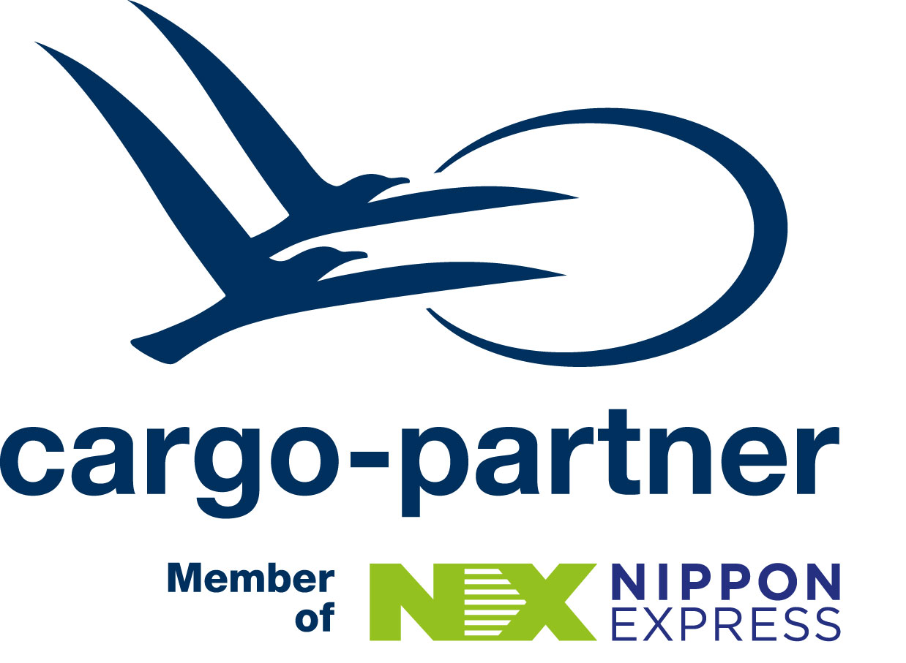


Autonomous non-GPS Indoor Drones Revolutionize Inspections
Fischamend, Austria, September 14, 2024

Spiral Launches in Austria with Drone Demo at cargo-partner iLogistics Center
Spiral Inc., a leader in automated indoor drone solutions, has just opened its new office in Vienna, Austria, Spiral Europe FlexCo (Managing Director: Miyu Nishihira). Today the leading indoor drone producer conducted an insightful drone demonstration at the cargo-partner iLogistics Center, the iconic wooden warehouse in Fischamend near Vienna International Airport. The event was further honored by the presence of the Japanese Ambassador to Austria, HE Ryuta Mizuuchi, underscoring the strong ties between the two countries and the significance of this technological collaboration.
Spiral Inc. is a Japanese company founded in 2016, which Nippon Express Holdings has invested in. cargo-partner has been a Member of the Nippon Express Group since January 2024, substantially strengthening the Group’s European presence with its powerful network in Central and Eastern Europe.
This expansion marks a significant first step in bringing Spiral’s innovative MarkFlex®Air (MFA) navigation system to the European market. Designed to overcome the challenges of non-GPS environments, the MFA technology provides autonomous drone monitoring for large-scale indoor infrastructure, including dams, tunnels, sewer systems and other underground structures. Independent of GPS, Spiral drones can operate in remote locations or near critical infrastructure such as airports, where GPS signals tend to be spoofed.
Miyu Nishihira, Managing Director, Spiral Europe FlexCo said: “We are excited to bring our advanced MFA navigation system to Europe. Austria’s mountainous landscape and central location in Europe make it the perfect hub for our expansion. We look forward to contributing to the sustainability of the construction industry by enhancing safety, fostering growth and drive innovation in infrastructure.”
“At cargo-partner, we are proud to combine innovation with sustainability in everything we do. Today’s presentation was a perfect example of the unified capabilities of the Nippon Express Group, Spiral Europe and cargo-partner,” stated Martin Schenzel, Managing Director of cargo-partner Austria.
Enhancing Safety and Efficiency in Infrastructure
Spiral’s cutting-edge technology addresses the need for safer and more efficient inspection processes in the construction industry. By minimizing the requirement for manual inspections, Spiral’s drones offer a solution to the shortage of skilled labor while improving worker safety and project efficiency. The MFA system, which enables easy, autonomous navigation through the use of Augmented Reality (AR) markers, allows for real-time video monitoring and data collection, all cloud-based to enable quick, data-driven decision-making.
In the next project phase, the innovative drone solution is planned to expand its sensor technology – including gas detectors, chemical sensors or microphones – depending on their tasks.
Proven Success in Japan, Ready for Europe
With a proven track record and successful pilot projects with Japan’s Ministry of Land, Infrastructure, Transport and Tourism and major Japanese construction companies, Spiral is well-prepared to extend its reach. The decision to establish a base in Vienna results from Spiral’s participation in the GO AUSTRIA program by the Global Incubator Network (GIN) Austria, where the company identified significant market opportunities with extensive tunnel projects commonly undertaken by European contractors.
Strategic Choice: In the Heart of Europe
Vienna offers a strategic location for Spiral’s European operations. Austria’s robust construction industry, supported by world-leading contractors and prestigious universities with civil engineering expertise, provides an ideal environment for Spiral to refine and expand its innovative solutions. Additionally, Austria’s access to public funding for research and development (R&D) further enhances Spiral’s ability to integrate its technology into the European market and effectively scale operations.
About Spiral Inc.
Founded on October 27, 2016, and headquartered in Katsushika-ku, Tokyo, Spiral Inc. specializes in automated indoor drone solutions. With its proprietary MarkFlex®Air technology, Spiral offers unparalleled customization in both hardware and software development, enabling seamless drone navigation and inspection without the need for GPS. Spiral continues to lead the industry in providing safe, efficient, and innovative solutions for infrastructure monitoring and inspection.
About cargo-partner
cargo-partner is a full-range info-logistics provider offering a comprehensive portfolio of air, sea, land transport and warehousing solutions. With over 40 years of expertise in information technology and supply chain optimization, the company designs tailor-made services for a wide range of industries to create competitive benefits for its customers all around the world. Founded in 1983, cargo-partner generated a turnover of over 1.3 billion euro in 2023 and currently employs more than 4,000 people worldwide. Since January 2024, cargo-partner has been a member of the Nippon Express Group.

For further information please contact:
Karin Schwarz | Corporate Director Communications & Marketing
Cargo-Partner Headquarter GmbH
Airportstrasse 9
2401 Fischamend, Austria
Phone: +43 5 9888-11322 |
Email: karin.schwarz@cargo-partner.com
Website | Trendletter

