Almaty Digital Forum 2023: Exploring the scope for Digital partnership in Changing World
Almaty, February 7, 2023
Digitalization is a force for change and a major driver of globalisation. The usage of digital technology in everyday life, such as the internet and smartphones, has made information access and processing more efficient, timely, and accurate. It has now become a worldwide phenomenon. Since 2005, developing nations’ global internet user base has increased exponentially. It would be surprising to note that more people now have access to digital technology than to secondary education or clean water. On the business front, digital business growth has become a worldwide trend. Businesses employ internet-based digital technology for research and development, manufacturing, and delivery of goods and services. This not only increases the possibility for commercial growth but also creates jobs.
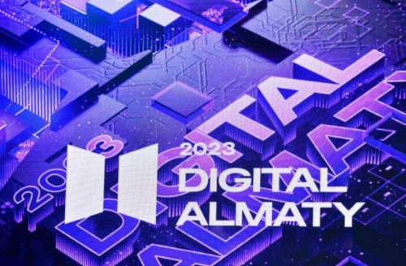
However, digitalization has permeated numerous activities, and practically all of them might be classified as part of a larger definition of the digital economy. Global finance is likewise being transformed by digitalization. Digital fundraising platforms generate new financial market platforms and enable more direct funding, including cross-border financing, without the need for traditional intermediaries. These digital global finance drivers are beginning to undermine the monopoly of traditional intermediaries, such as banks, in providing international money.
Kazakhstan has been a pioneer in the post-Soviet era’s digital development. International organizations have taken note of Kazakhstan’s progress in the digitalization sector. Considering the importance of the digitalization process in a globalized world, Kazakhstan, the largest Central Asian nation with the highest economic growth in the region, has initiated to hold an annual Almaty Digital Forum. On 2-3 February 2023, the fifth edition of this annual forum was held in Almaty. The forum’s agenda included 20-panel discussions attended by almost 150 speakers from the international and Kazakh IT communities. Over 15,000 participants from 30 nations participated in the event.
This forum offers a valuable platform for the country’s youngsters to demonstrate understanding. As we all know, the youth are the World’s future. Thus, technological and digital advancement in all sectors of society is essential. Almaty digital forum has a lot of promise in this sense. The discussions centered on the rapid shift of industries from automation to digitalization, opportunities for digital mining, robotization applications, and the growth of the Eurasian IT sector. The heads of governments of Eurasian Economic Union (EAEU) member nations have also attended the Digital Almaty forum’s plenary meeting. The forum focused on developing long-term digital infrastructure and innovative telecommunications technologies.
In his speech at the forum, the Prime minister of the republic of Kazakhstan Mr. Alikhan Smailov, emphasized that digitalization is a key component in providing equal opportunity and fairness for all people of the country. In other words, digital development aids in overcoming the societal challenges present in practically all EAEU nations. His views on the subject are fully reinforced by the country’s continuing reforms, which seek a just and fair Kazakhstan. His counterparts from the other member countries of the EAEU also highlighted the importance of digitalization and innovation in today’s rapidly changing environment.
The forum also looked at how digitalization could strengthen the socio-economic condition of women in society. Most businesswomen own and operate small and medium-sized enterprises. Lyazzat Ramazanova, vice chair of the National Commission for Women, Family, and Demographic Policy, observed this remarkable growth of female business in Kazakhstan. According to Aset Turyssov, vice minister of digital development, innovation, and aerospace industry, Kazakhstan encourages women by making it easier for them to use socialized public services. He mentioned how the service is doing more to assist women.
The Almaty Digital Forum offers a distinctive platform for entrepreneurs from like-minded nations to present their work. It also creates opportunities for more cooperation to advance this industry. The Almaty Digital Forum might offer some real solutions to digitalization issues, such as cyber security, etc. In this sense, the forum has a lot of potentials.

Author:
Dr Pravesh Kumar Gupta
Associate fellow VIF

