Petr Pravoslav Švihovec: Bracelet of an American war veteran
Prague, December 16, 2021
In October, my friend Václav and I went to a former prison camp near Mariánské Lázně to try our luck with a metal detector. It was only the third time this year, so I wanted to really enjoy it. Little did I know that I would find a novel story that day.
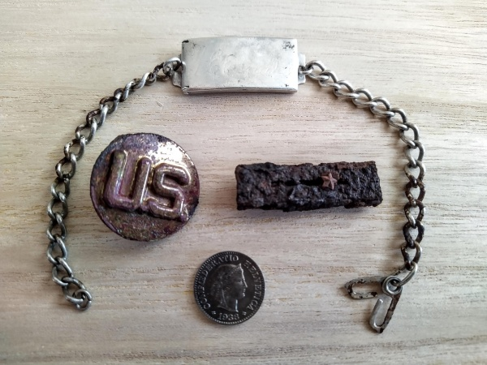
After a moment of searching, a nice signal came. I sat on the ground and started digging. I found a piece of decoration with one star. And just below it is a collar badge with the letters US. It was clear that these were things after the American soldier from the end of the war. I tried to wave the detector over the hole again and the signal repeated. I already pulled the silver bracelet out of the ground. I was mainly interested in the inscriptions on it. Soldier's signature and the name of his girlfriend Lydia. My heart pounded. I felt a special desire to find out who belonged. But how?

At home, I cleaned the bracelet and tried to decipher the soldier's signature. But I couldn't. That's why I turned to the Treasure Hunters Facebook group with help. We deciphered the signature all day. Perhaps thirty proposals were made. I tried to search them all on the internet, but in vain. And then it came. It occurred to me to enter the surname Esquibel. It turned out to be quite common. Then I wrote Lydia Esquibel. The parte of a woman who was born in 1926 and died in 2019 appeared. Could it have been a woman from a bracelet? Then I noticed her husband Joe's name among the bereaved. That was a lot of coincidences!

The army document sent to me by historian Daniel Malý from Pilsen was a huge help. They were about soldier Joe Ernest Esquibel. I believed it might be him, but the last piece of evidence was missing. Namely the signature. He was illegible on the document. Soon Daniel sent another document. And the signature on it matched the signature on the bracelet!

Plus, there was hope that Joe was still alive! That's why I turned to the Pentagon. But I didn't go there. And not on various American Facebook groups about war veterans. Unfortunately, no one from the US Embassy in Prague responded to the emails, it was not possible to call there either. I didn't want to give it up. I decided to give a call to my Facebook. However, I did not expect much favorable reactions, due to the fact that the topic of search engines is still controversial and often arouses passions. But it was quite stolen from me, because I just wanted to find the guy!

Subsequently, people began to share my challenge. Among them is a friend Lucie, who shared my contribution to the page Czechs living in the USA. Mrs. Hana shared it there and Alena Bušovská from Grand Junction noticed the call. That's where Joe was supposed to live. Alena wrote me that she would try to go there. And she really did. She met his daughter. In the meantime, I sent her an email with photos of the bracelet. And then something I didn't even hope for happened. They printed the photos and showed the old man. Joe recognized his stuff immediately! Tears welled up in my hand as a photo of the war veteran holding my printed email.
At the respectable age of 95, Joe began to remember what had happened then. He had a hard fight in Western Europe, where he lost a lot of friends. In the autumn of 1945 he arrived in Mariánské Lázně. His task was to guard the prison camp. There, someone stole his backpack with personal belongings. He also had the only pistol in it. The theft was not investigated because there was no time. After an agreement with the Americans, the Red Army had just arrived at the prison camp, taking all German soldiers serving on the Eastern Front and members of the SS. In January 1946, Joe returned home. Three years later, he took the love of his life from a bracelet to a woman. They spent almost seventy years together before his beloved Lydia closed her eyes forever.

The story got into the Czech media, which pleased Joe as well. But I had only one thing left. Deliver the bracelet back home as safely as possible. That's why I went to the US embassy in person. Fortunately, there was a man there, spokesman Jakub Hornek. He told the story to the United States Marine Corps. The Marines were thrilled! Within a few days, I was invited to the embassy, ​​where I handed them the war veteran's belongings. The handing over of the bracelet itself was very emotional. The American soldiers thanked me and shook my hands. I really enjoyed it.

In a few days, Joe had a bracelet on his arm. After an incredible 76 years! I've been preparing for Joe's photo with the bracelet all along. But there was also a video. I saw Joe talking, moving. Suddenly I realized what had happened. I cried all night and all morning. Good luck! I had to postpone the TV interview to the next day.

Joe is rightly proud because the bracelet story is currently being conquered by the American media. I'm happy that the story of the bracelet was made to the very end. I don't think anyone has yet found a person by signing, after such a long time and on the other side of the world.

My biggest dream is to shake Joe's hand and hug him. I believe I can do it…

