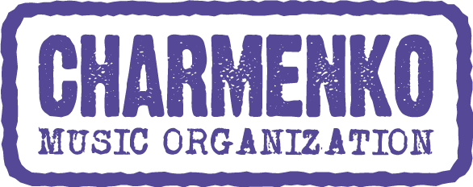

ARCTIC MONKEYS RETURN TO CZECHIA AFTER THIRTEEN YEARS!

Arctic Monkeys return to live arena with their first shows since their “Tranquility Base Hotel + Casino tour”, which ended in 2019. Their long-awaited Prague show will take place on August 18, 2022 at Výstaviště Praha. The sale of personalized tickets will begin on Wednesday, November 24, 2021 at 10 am via GoOut and TicketMaster. The show is promoted by Charmenko CZ.
Arctic Monkeys are Alex Turner, Jamie Cook, Nick O’Malley and Matt Helders. Formed in High Green, Sheffield in 2002, the band have released 6 studio albums to date, their most recent, ‘Tranquility Base Hotel + Casino’ released in 2018. The band also released their first live album ‘Arctic Monkeys Live At The Royal Albert Hall’ (2020) with all proceeds going to War Child UK.
The band’s debut album ‘Whatever People Say I Am, That’s What I’m Not’ became the fastest selling debut album in UK chart history on its release in 2006.
The release of subsequent albums ‘Favourite Worst Nightmare’ (2007), ‘ Humbug’ (2009), ‘Suck It And See’ (2011), ‘AM’ (2013) and ‘Tranquility Base Hotel + Casino’ (2018) has consolidated their position as one of the most successful British bands to emerge in recent times. They are the only band to have won both Best British Group and British Album of The Year at The Brits three times. The band has now won 7 Brit awards out of 9 nominations since their debut album in 2006. Other achievements include an Ivor Novello award, a Mercury Music Prize, 20 NME awards, 5 Q awards and 3 Grammy nominations.
With global album sales of over 25 million and a digital fanbase of over 30 million followers, the band's music has been streamed more than 9 billion times to date, accruing on average 6.5 million streams every day. Their legendary single 'Do I Wanna Know' has been streamed 1 billion times alone.
Arctic Monkeys performed at the opening ceremony of The Summer Olympics in London in 2012 and have headlined both the Glastonbury and Reading and Leeds Festivals twice. The band sold over 625,000 tickets worldwide during their ‘Tranquility Base Hotel + Casino’ tour in 2018 and 2019.
Alex Turner has now released 8 consecutive UK number one albums (6 x Arctic Monkeys, 2 x The Last Shadow Puppets).
+++

Arctic Monkeys:
https://www.arcticmonkeys.com/
https://www.facebook.com/ArcticMonkeys

Facebook event:
https://www.facebook.com/events/434282528107941

Music:
https://www.youtube.com/watch?v=bpOSxM0rNPM- Do I Wanna Know?
https://www.youtube.com/watch?v=VQH8ZTgna3Q - R U Mine?

https://www.youtube.com/watch?v=6366dxFf-Os&t=7s - Why'd You Only Call Me When You're High?

Promoter:

Martina Machová
+420 731 814 881

maya@charm-music.eu
Charmenko Czechia

More info:

www.facebook.com/CharmenkoCZ

