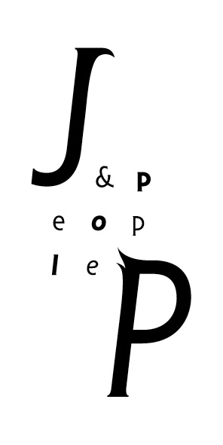

The Greatest Show returns with a new coat! The second season will be presented by the Vinohrady Theater.

Prague, 3rd February 2020: The popular concert show by the art agency JP & People, which features music from the highly acclaimed movie “The Greatest Showman”, has found a new home. After the successful first season in the Hybernia, Prague, “The Greatest Show” with the subtitle “Reincarnation” has moved to the renowned stage of the prestigious Vinohrady Theater. The premiere of the concert, whose format has undergone some enhancements, will take place on Sunday, May 3, 2020.
The Vinohrady Theater is remarkably reminiscent of the original theater in Barnum’s American Museum, and this provides a nostalgic setting for the returning production. To complete the authenticity of the experience, there will also be newly introduced accompanying off stage programs. The so-called "Imaginarium" invites visitors to step into the world of the original, old-style American circus, which will include cotton candy, popcorn, tarot cards, tombola and other attractions. A thematic exhibition of original visuals “P.T. Barnum: The legends begins...” then introduces the theater visitors to the personality and story behind the pioneering circus master and promoter who served as inspiration for the original movie.
The concert itself will undergo some minor adjustments to accommodate its new home, and will also offer full English performances for foreign audiences. It is not just the main part of P.T. Barnum, in which the winner of the Thalia Award Pavel Kříž alternates with Martin Šemík, who will perform in new creations Lettie (Andrea Holá), Jenny Lind (Iva Marešová), James Bailey (Martin Růža) and stilt man Miguel Dytrych will also receive new costumes from Roman Šolc. Furthermore, we will see Petra Vojtková in the role of Charity, and Filip Antonio in the role of the young Barnum. Tokhi & the Groove Army will serve as an unconventional rhythmic boost and the lively brass band Lovesong Orchestra with bandmaster Tomáš Průša will again provide an original introduction.
Jiří Peter, director of The Greatest Show and Managing Director the JP & People art agency, said:
“When I turned on the music from the movie at the Vinohrady Theater and looked around, I knew that this was the right choice for The Greatest Show. In addition, we are going to enrich the program with more activities, so even those who come to see the show for a second time can look forward to new experiences!”
As part of the “Dreams by JP” project, The Greatest Show will continue to fulfill the dreams of spectators at the end of each performance and concert goers can already start sending their wishes to production@jiripeter.com. In the past, this project has featured a marriage proposal, a duet by the handicapped Kačka alongside the character of Barnum, a performance from a young majorette group from Prague, and a moving “thank you” to the adoptive mother of Michal Hájek.
The Greatest Show is composed of Pasek & Paul's Oscar-winning songs such as “A Million Dreams” and “This Is Me” in their original English versions. The concert will be performed at the Vinohrady Theater on 3.5., 27.6., 6.9. and 8.11., always from 15:00 and 20:00. The afternoon performances will be accompanied by a Czech narrator and the evening performances will be fully in English. Tickets from 990 - 1560 CZK are already on sale at Ticketmaster and the earlier the purchase, the better the price.
Ticketmaster also offers a “Meal Deal'' package, which includes a voucher for lunch or dinner at a variety of adjacent partner restaurants, or a special “Experience by JP” ticket, with which Jiří Peter takes the viewer personally behind the scenes and guides them through the creation of the show. VIP tickets “JP Royal Bed” at the serviced lodge with a welcome drink will also be available in the Ticketmaster offer. Fans will also be able to purchase a variety of souvenir packages, and the opportunity to take a photo with the performers at “The Greatest Boutique”.
For more information about The Greatest Show and other JP & People activities, visit www.jiripeter.com/TGSR.

The Greatest Show:
The Greatest Show is a theatrical concert celebrating the life and success of the American businessman and founder of the circus P.T.Barnum. The concert is composed of music by Oscar-winning author duo Benj Pasek & Justin Paul, written for the movie "The Greatest Showman".
Phineas Barnum's most famous quote is: "The noblest art is that of making others happy.” This is the emotion which The Greatest Show wishes to evoke for its audiences.

Author Team:

Music and lyrics: James Pasek, Justin Paul
Creator and Director: Jiří Peter
Producer: JP & People
Musical Preparation: Aleš Háva a Tokhi
Singing Preparation: Iva Marešová
Choreography: Ivana Hannichová
Costumes: Roman Šolc
Scenography: Pavel Svoboda
Light design: Lukáš Dřevjaný
Sound design: Petr Janeček
Production: Kristýna Daňková, Hana Hošková

Notes for Editors:

The JP & People production agency consists of two teams. One focuses on original productions for the public, and from this teams’ work you could have recently noticed “The Greatest Show - Live in Concert” on Prague’s theatre scene. The other team puts on performances for private events. They currently offer, for example, performances by African musicians and dancers entitled “Spirit of Africa” and a play for children called “Once Upon a Time”.

JP & People includes professional artists, creatives, dancers, singers, acrobats, musicians and other performers, production workers and technicians. Under the direction of producer Jiří Peter, they create magical productions that will take you away from your everyday life to places you have forgotten or have never known.

Contact for Media:

Barbora Müllerová
PR Boutique Prague
bara@prboutique.cz
+420 605 119 944

