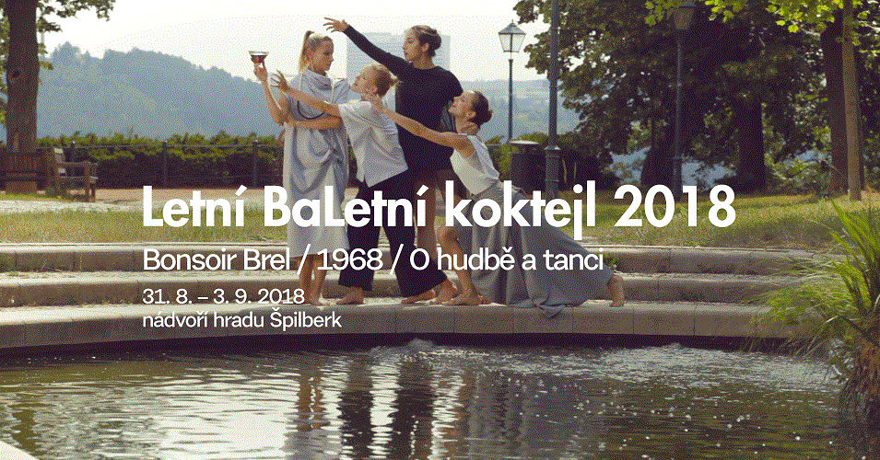

Balet NdB Open Air
Summer Ballet Cocktail 2018

Bonsoir Brel / 1968 / O hudbě a tanci
Choreography: Markéta Pimek Habalová, Mário Radačovský, Martin Svobodník

After last year’s successful summer production at the Bishop’s Courtyard (Biskupský dvůr), the Brno National Theatre Ballet will this year team up with the opera company and together they will symbolically besiege Špilberk Castle. This will be a new and exclusive space to present audiences with another year of open air performances, entitled Summer Ballet Cocktail.

We have three new choreographic arrangements created specifically for this occasion. These will be from the work of ous soloist Martin Svobodník, demi-soloist Markéta Pimek Habalová, and the company’s artistic director Mário Radačovský, whose choreography in the eighth year will be symbolically devoted to 1968.

Not only will we have serious themes, we primarily want to entertain you, and in late summer tune you in to the new 2018/19 ballet season, with some great productions in store for you. Come and sample the 2018 Summer Ballet Cocktail and freshen up your summer in the open air with Brno National Theatre Ballet!

More info: http://bit.ly/LBK2018 and facebook: @baletndb

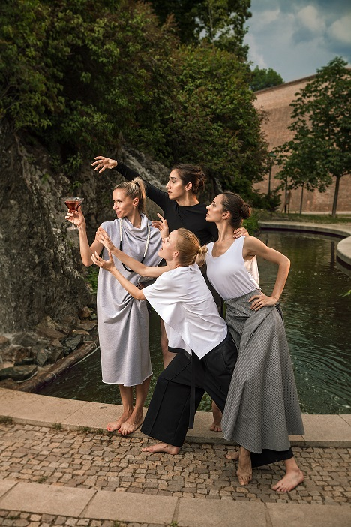
Photo: Jakub Jíra

Contact:
- Ing. Barbora Hniličková (marketing and PR)
  - Tel: + 420 603 858 488
  - Email: hnilickova@ndbrno.cz

